***Mr. Driller User Guide***

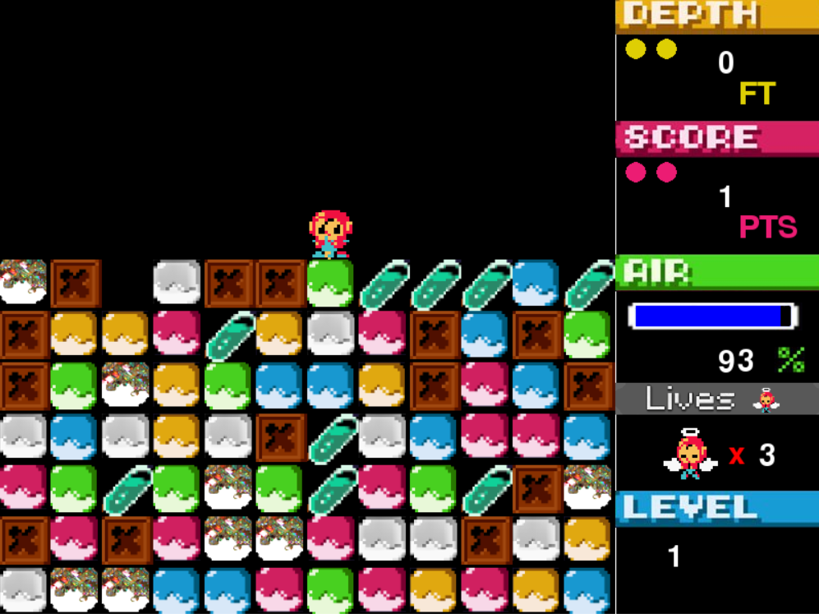

**The Story of The Game**

Mysterious colored blocks suddenly appear from the earth, they come from 1000m beneath.

The whole town is in panic. What shall we do?

That’s right let’s call Mr. Driller!

Go Driller Go !

**The Game**

Mr. Driller is a 2D puzzle game. The player controls a driller and has several levels to achieve. The main goal of each level is to dig until its depth without lacking air or being crashed by a falling block.

**Moves and actions of the driller**

The driller can move left or right at the same elevation or in climbing one block. He can also drill a block located leftward, rightward or downward. If there are no blocks anymore under his feet, he falls down by gravity.

**Blocks**

There are regular blocks colored in red, blue, green or yellow. When the player drills one of this block, he simultaneously drills the adjacent blocks of the same color. All blocks above them fall down by gravity.

When regular blocks fall down after some drilling, they merge with adjacent blocks of the same color and stop their falling. If at least four blocks merge, they disappear.

There are also special blocks:

• The brown ones need five drill hits to disappear and must be drilled one by one. However, they merge after falling with the same property of disappearance that the regular blocks.

• The white ones don't merge with other blocks of the same color.

• The crystal ones have a short lifetime before disappearing.

**Air**

The player has an air supply which decreases by one percent by second. Drilling a brown block costs twenty percent all of a sudden. The player can collect air capsules which increase his supply by twenty percent.

**Score**

Each block drilled or disappeared after merging brings points. The player also increases his score by collecting air capsules. He finally has a bonus after completing a level.

**Lives, win/lose**

If the air supply falls to zero percent or if the driller is crashed by a falling block, the player loses a life and restarts at the same depth with a full air supply.

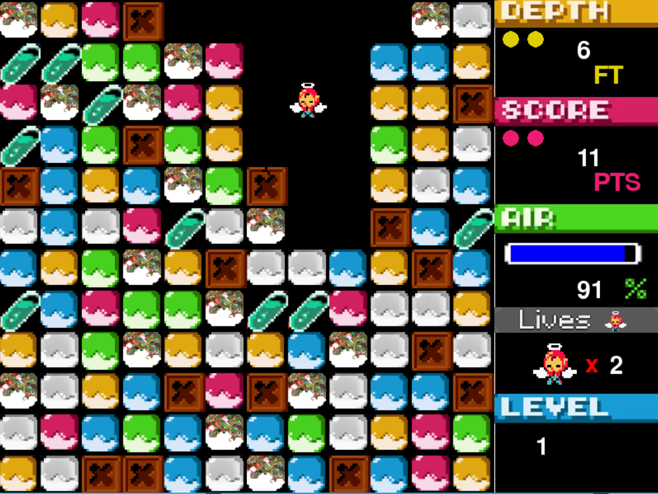When the player loses his three lives the game is over. He wins if achieves all the levels.

**Instructions of the game**

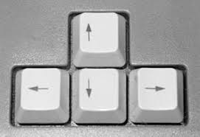

Use arrow Keys to move the character:

-Left key to move left.

-Right key to move right.

Use Space bar to climb a block.

Use A, Z and E Keys to drill blocks:

-Press A key to drill a block on the left.

-Press Z key to drill a block in the bottom.

-Press E key to drill a block on the right.

 